**PRACTICAL 4**

**COMPUTER ORGANISATION AND ARCHITECTURE**

|  |  |
| --- | --- |
| **NAME: VARUN KHADAYATE** | **ROLL NO: A016** |
| **PROGRAM: BTECH SY** | **DIVISION: CSBS** |
| **BATCH: 1** | **DATE OF EXPERIMENT: 02/09/2020** |

**AIM**

**Construction of half/ full adder using XOR and NAND gates and verification of its operation**

**THEORY**

Full adder is a digital circuit used to calculate the sum of three binary bits which is the main difference between full adder and half adder. Full adders are complex and difficult to implement when compared to half adders. Two of the three bits are same as before which are A, the augend bit and B, the addend bit. The additional third bit is carry bit from the previous stage and is called 'Carry' – in generally represented by CIN. It calculates the sum of three bits along with the carry. The output carry is called Carry – out and is represented by COUT.

The block diagram of a full adder with A, B and CIN as inputs and S, COUT as outputs is shown below.

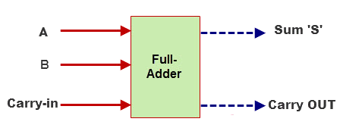

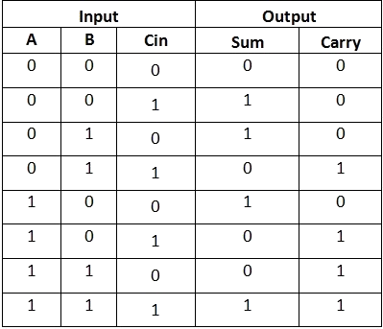  
**Full Adder Block Diagram and Truth Table**

Based on the truth table, the Boolean functions for Sum (S) and Carry – out (COUT) can be derived using K – Map.

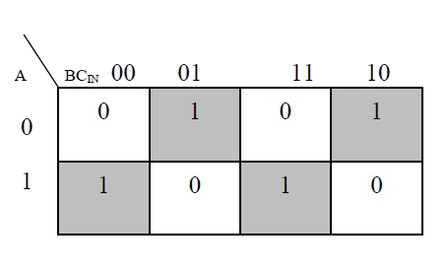

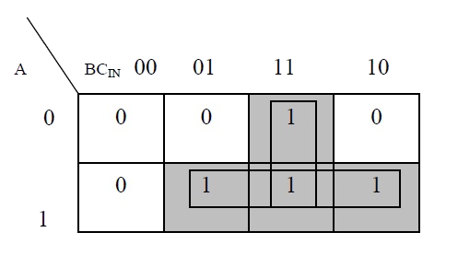

The simplified equation for sum is S = A'B'Cin + A'BCin' + ABCin  
The simplified equation for COUT is COUT = AB + ACIN + BCIN

In order to implement a combinational circuit for full adder, it is clear from the equations derived above, that we need four 3-input AND gates and one 4-input OR gates for Sum and three 2-input AND gates and one 3-input OR gate for Carry – out.

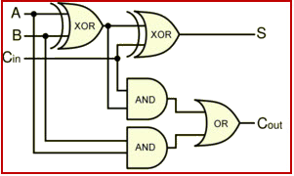

**Full Adder Logic Diagram**

#### **2.1) Full Adder using NAND gates**

As mentioned earlier, a NAND gate is one of the universal gates and can be used to implement any logic design. The circuit of full adder using only NAND gates is shown below.

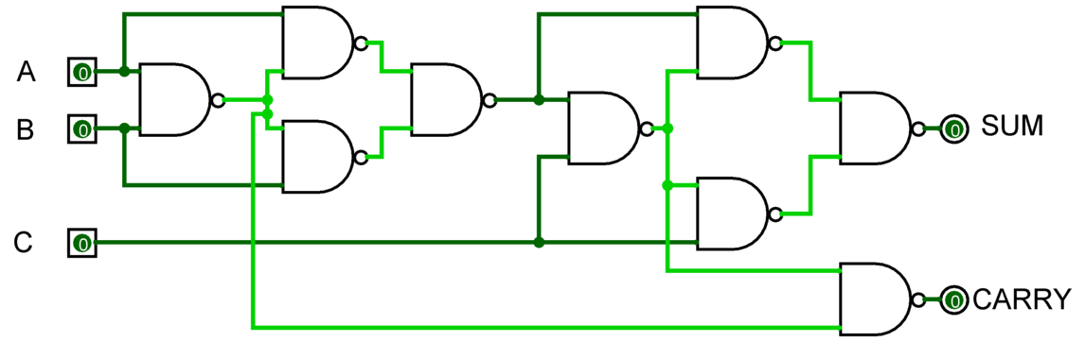

**Full Adder using NAND gates**

#### **2.2) Full Adder using NOR gates**

As mentioned earlier, a NOR gate is one of the universal gates and can be used to implement any logic design. The circuit of full adder using only NOR gates is shown below.

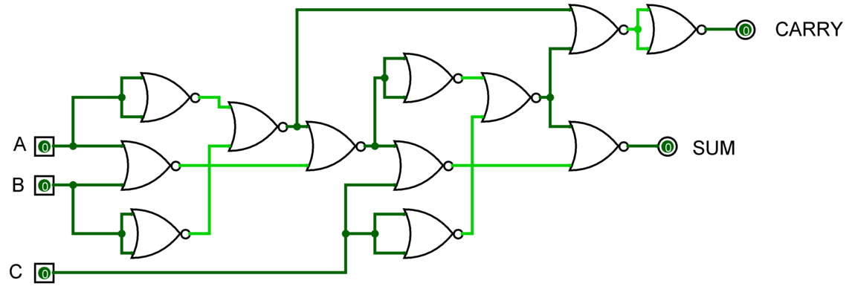  
**Full Adder using NOR gates**

**SIMULATION**

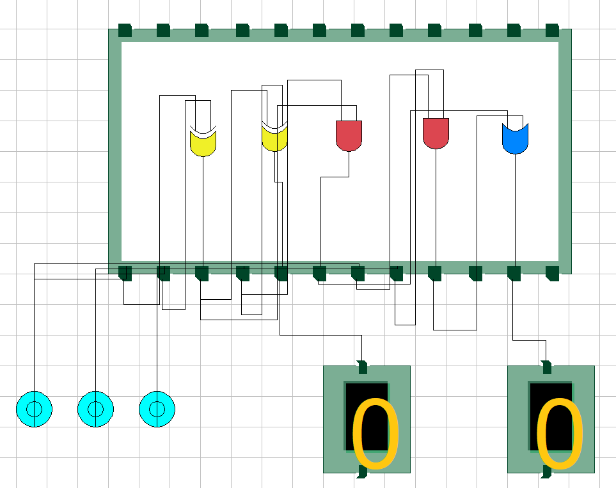 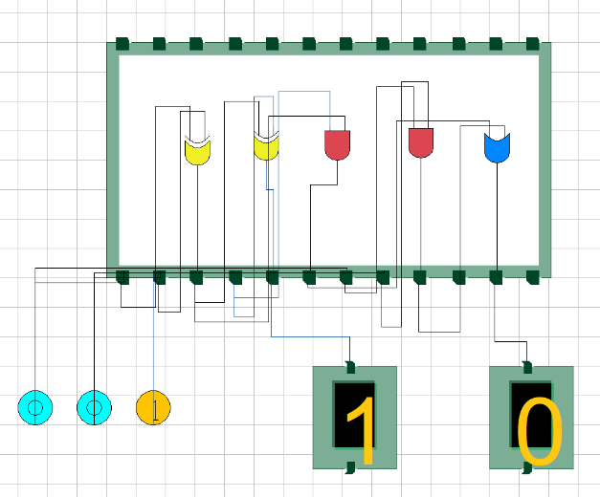

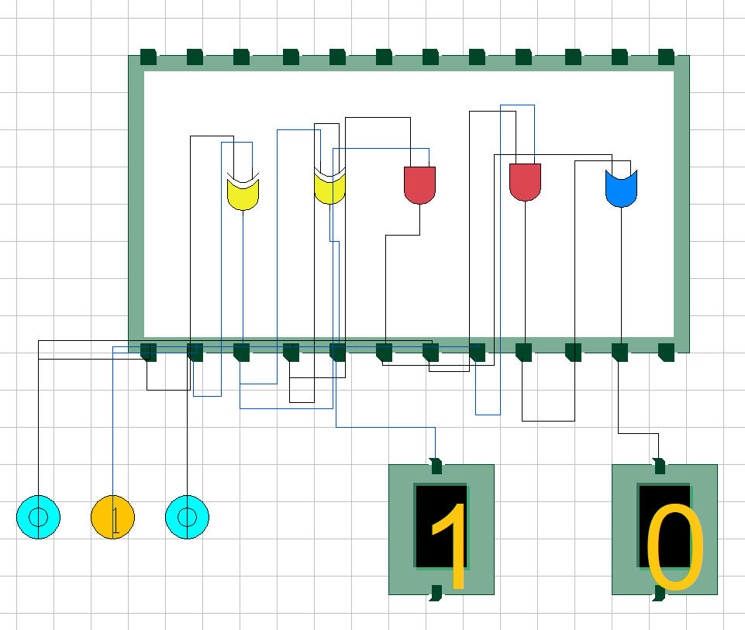 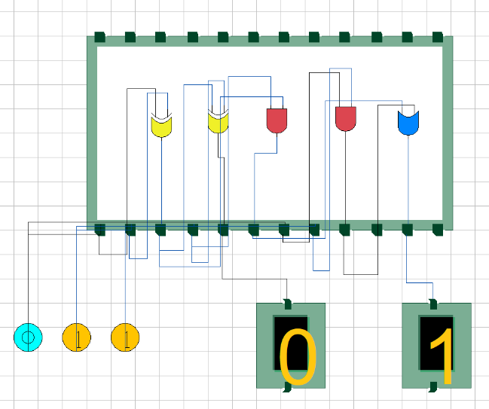

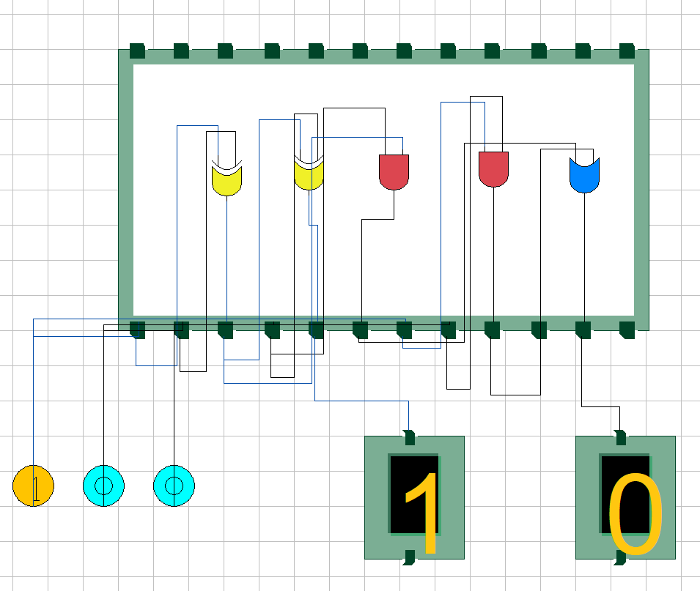 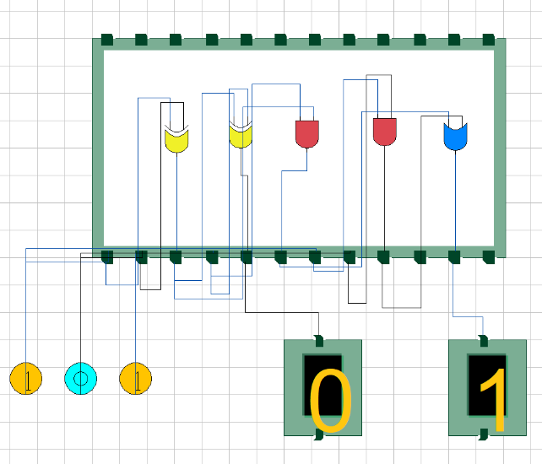

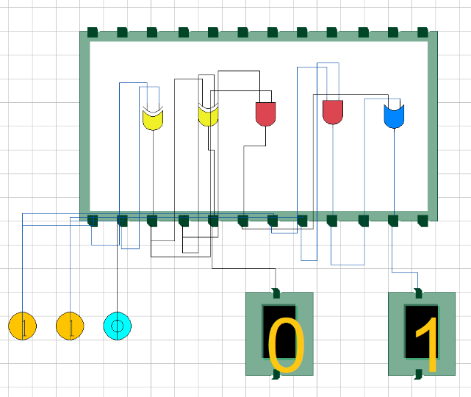 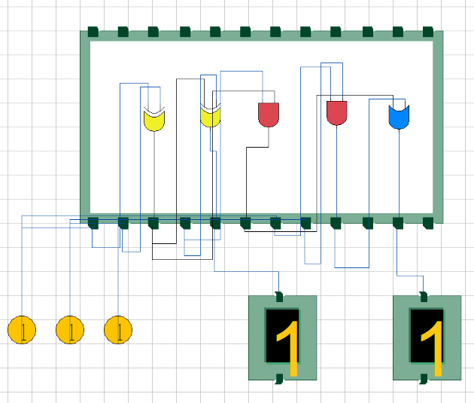

**CONCLUSION**

Hence, we are able to verify and study the functionality of a full adder